Current Complaint: Date:_____________________
Name:_____________________________________________________ Date of Birth:______________
Reason for visit:_______________________________________________________________________
Pain Level: None 0 1 2 3 4 5 6 7 8 9 10 Worst
Additional Complaints:___________________________________________________________
When did the symptoms begin? __________________________________________________
Have you had similar symptoms prior? Yes  No If so, when? _________________________
What this caused by? 
Slip/Fall  Car or Work Accident  Gradual Onset  Sports Injury   Other?___________
Is the pain?  Constant  Frequent, but not constant  Occasional  Activity Induced:____________
Do you feel pain has changed since initial onset:________________________________________
What have you tried that has decreased the pain? ___________________________________________
Have you seen any other medical providers for these symptoms?  Yes  No
Provider name and type:________________________________Dates:__________________________
Any surgery/injections or previous trauma to the area? Yes No Did it help? Yes No
Have you had any of the following of the injured area? X-Ray MRI CT Bone Scan EMG Other
Medical History
Any other previous surgical history? Dates?____________________________________________
Are you being treated for any other condition?________________________________________
Have you ever been involved in an auto accident, if so, when?__________________________
Have you had chiropractic care previously, if so, when?________________________________
Have you ever been diagnosed with any of the following? If so, list when and current status:
Arthritis_____________________ Cancer_________________________
Stroke______________________ Pacemaker/Heart Issues______________________
Diabetes____________________ High/Low Blood Pressure_____________________
Pregnant (Y/N)_______________ Other______________________________________
Do you have a family history of any of the following? If so, relationship to you:
Arthritis_____________________ Cancer_________________________
Stroke______________________ Pacemaker/Heart Issues______________________
Diabetes____________________ High/Low Blood Pressure_____________________
Other_______________________________________________________________________
Are you taking any medications or vitamins or supplements currently? If so, list below _____________________________________ Smoke? Yes No Drink? Yes No Exercise? Yes No
Current Work Status: ___Regular Duty ___ Light Duty ___ No work Hours per week:____________
Occupation: ________________________________________

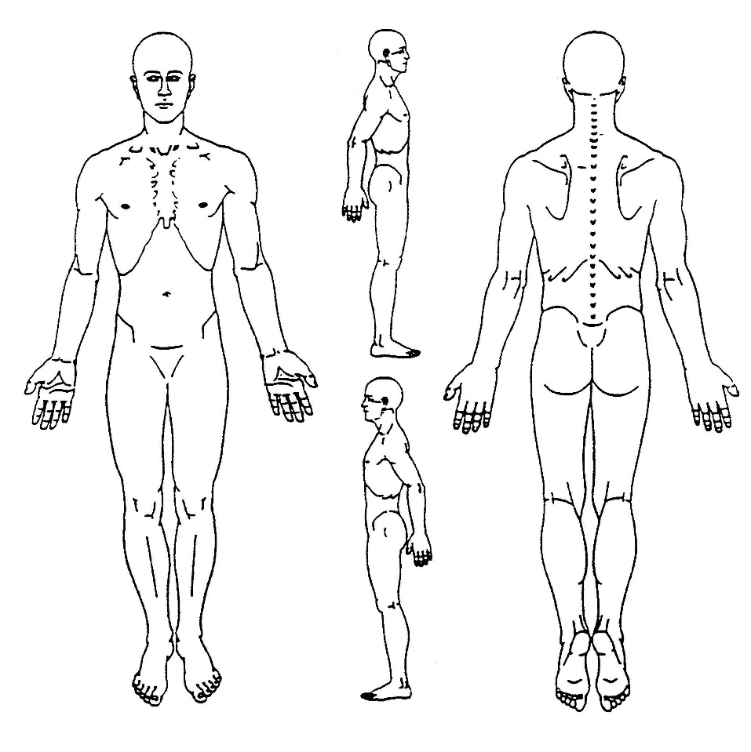
Please mark on the figures below where you are experiencing pain:
Please describe the quality of your pain:
___Dull ___Achy ___Sharp ___Stabbing ___Tingling ___Numb ___Throbbing

Please only answer questions related to your complaint, check all that apply:
Neck:
Do you have headaches? [ ] ~ Frequency: _____/month
Dizziness? [ ] ~ Frequency: _____/month Blurred Vision? [ } ~ Frequency: _____/month
Are you experiencing arm or hand pain/numbness/tingling? [ ] Is it worse recently? [ ]
Do you feel like your hands are consistently cold when they shouldn’t be?  [ ]

Mid Back (Recent Changes Only):
Are you experiencing pain with deep breaths? [ ] Any chest Pain? [ ]
Have you noticed heart palpitations or flutter? [ ] Have you noticed difficulty breathing? [ ]

Lower Back Pain:
Noticing any new leg pain/numbness/tingling? [ ] Leg weakness? [ ] Cold Feet? [ ]
Recent change in bowel/bladder habits?  [ ] Groin Numbness? [ ]

Signed: ___________________________________ Date: ______________________________

